(Approx. 973 words)

Two if by Land, one if by Air
By Phil Sorrentino, Newsletter Contributor, Sarasota Technology Users Group
www.thestug.org
philsorr (at) yahoo.com
Well, that may not quite be the famous quote “One if by land, two if by sea,” that allowed Paul Revere to signal the patriots how the English army was coming. But the idea may be similar. Here it’s a statement of choices, and in this case, the option is how the internet is connected to your home. Until recently, the only choice was “by land.” (Yes, I know there is DishNet [communications-satellite provided internet], but that is a reasonably small percentage, and it doesn’t fit in my metaphor-simile.) There are two land delivery methods in this general area of southwest Florida, cable, and fiber. In the Sun City Center area, Spectrum will provide internet to your home via a cable-TV type of cable brought right into your home. (Brighthouse was the provider until 2015 when Charter Communications acquired Brighthouse and folded it into Charter Spectrum.) The other land internet provider is Frontier Communications. Frontier provides the internet via fiber optic cable brought right to your home. (The actual cable brought into your house may be fiber, but more typically, the fiber signal is converted to a cable-TV signal at the entry point, and a cable-TV type of cable is brought into the house.) Verizon installed all the fiber in the Sun City Center area, and then in 2016 sold that part of their business to Frontier.
So that’s the two land choices, now for the air choice. The air choice is 5G wireless to the Home. Until 5G, distribution of the internet via wireless may not have been considered practical by Internet Service Providers for various reasons. But 5G’s frequency spectrum, modulation schemes, and bandwidth appear to make it a practical way to connect homes to the internet. Keep in mind that this is a way to connect the internet to the house. Once the home is connected, you don’t need a 5G phone to use the internet; Wi-Fi connects all your devices in the home to the internet. (A 5G phone is still required if you want to access internet resources directly using the 5G network.)
Just a brief review:
1G - The first generation of wireless systems was voice-oriented, analog cellular,

2G – The second generation was voice-oriented digital cellular,

3G – The third generation changed the emphasis from voice to data,

4G – The fourth generation increased the available bandwidth,

5G – The fifth generation continued to improve the available bandwidth and speed.

Most of us use phones that can take advantage of the 3G and 4G networks, though some newer, more expensive phones can use the 5G network. Here are some of the major features of the five generations. For those with technical curiosity notice the bandwidth improvement; it went from Two Thousand bps to over One Thousand-Million bps.
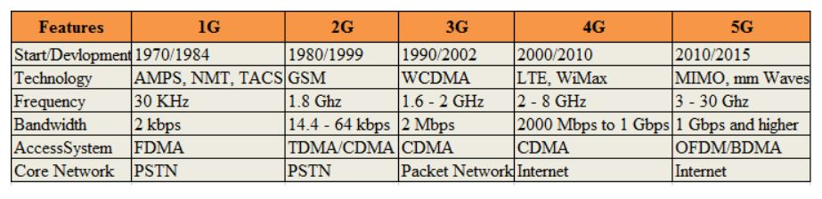
Advertising for 5G states that 5G Wireless Technology is intended to deliver higher multi-Gbps data speeds, ultra-low latency, more reliability, increased network capacity, and availability, and provide a more consistent user experience for more users.
5G Internet to the Home is currently only available in certain cities. A recent estimate for T-Mobile indicated about 30 million people in about 40 states. So more than likely, all three major internet companies, Verizon, AT&T, and T-Mobile, will eventually provide 5G Internet to the Home in many geographic areas, even if you are not seeing any advertising for it right now. (The only advertising I’ve seen so far was an article that indicated that T-Mobile and Verizon services would be $50/month with no contract, no equipment charges, no added fees, and no data caps. We’ll see.)
If you Google “5G internet to the Home,” you will find websites that may help you determine if 5G to the Home is available in your area. T-Mobile and Verizon seem to have the most presence if the number of hits on Google is any indication. Verizon currently offers 5G internet to the home, referred to as “Verizon 5G Home Internet”, in selected geographic areas. I tried a Verizon site with my address and concluded it is not available in Sun City Center at this time. However, Verizon offered LTE Home Internet service for $60/month if I was interested. (LTE stands for Long Term Evolution. It is a term used for a particular type of 4G network that delivers fast mobile internet service.) I also learned that the T-Mobile offering is called “T-Mobile Home Internet” and that AT&T currently only offers a 4G Home Internet. After trying a few other websites, I concluded that 5G Internet to the home is probably not available from any of the three providers at this time in most places.
“5G Internet to the Home” is also called “Fixed Wireless 5G”; to differentiate it from “5G Mobile,” which is the standard wireless service that supports our smartphones. Fixed Wireless refers to the equipment used to convert the 5G signals into an internet service. Fixed Wireless Internet is created from a fixed antenna connected to a nearby (and in the line of sight) wireless tower. The fixed antenna receives signals from the wireless tower, which it then sends to a router in your home to provide your home with local Wi-Fi access.
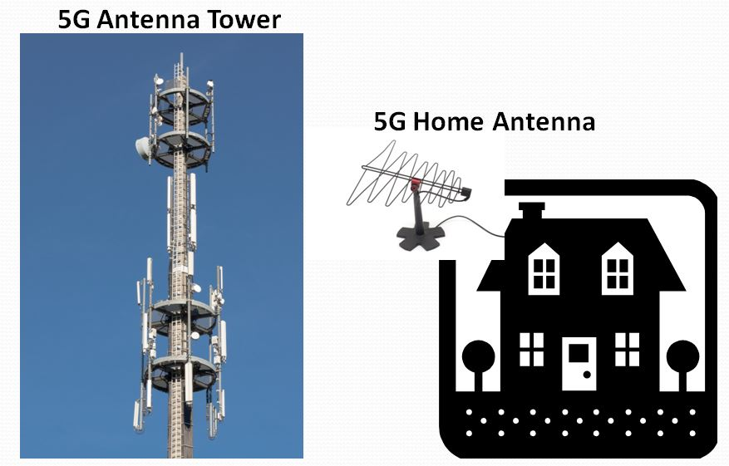
5G Internet to the Home
5G Internet to the Home providers advertise that this type of Internet distribution will come with benefits such as higher connection speeds, with a potential to reach 1,000 Mbps, and lower latency. This parameter affects buffering while streaming movies and video chatting. Another benefit cited is that the installation is pretty simple and that, in many cases, it can be installed by the end-user. Additionally, they are projecting higher reliability, lower prices, and no contract or hidden fees. We’ll see how all this works out as 5G Internet to the Home becomes available in more and more locations.

